Module-3 | Harmony in the Family and Society : (3 hours)
Harmony in the Family – the Basic Unit of Human Interaction, 'Trust' – the Foundational Value in Relationship, 'Respect' – as the Right Evaluation, Other Feelings, Justice in Human-toHuman Relationship, Understanding Harmony in the Society, Vision for the Universal Human Order

Every human being is born in a family and is part of a family. The family is the basic unit or building block of human organisation. It provides a base for appreciating, accepting, understanding and practicing to live in relationship and harmony (order).

Feeling of Relationship as the Basis for Harmony in the Family
The harmony in the family has primarily to do with the fulfilment of relationship between one human being and the other human being. In order to fulfil relationship, it is necessary to understand relationship.

Understanding Relationship
We will now explore into the four important aspects of relationship:
- Relationship is – between one Self (I1) and another Self (I2)
- There are feelings in relationship – in one Self (I1) for the other Self (I2)
- These feelings can be recognised – they are definite
- The fulfilment of these feelings and their right evaluation lead to mutual happiness
- Relationship is – between one Self (I1) and another Self (I2)
Relationship is already there. We do not have to construct or create relationship. All we need to do is to understand relationship and fulfil it.

Relationship is between one Self and the other Self. It is the Self which is recognizing the relationship, and not the Body. It is the Self which relates to the other, and not the Body.

- There are feelings in relationship – in one Self (I1) for the other Self (I2)
The important issue in human relationship is that of the feelings. We can see that feelings are in the Self, not in the Body. It is the Self which has the feelings and which recognises the feelings. To understand relationship, one has to understand the Self and the naturally acceptable feelings in the Self.

- These feelings can be recognised – they are definite
These feelings can be recognised, they are definite. There are nine feelings in relationship. These are the feelings which we can understand, which we can ensure within ourselves, which we can share with others and thus ensure mutual fulfilment in relationship. These are the feelings which are naturally acceptable to us in the relationship with the other human being.
Feelings (values) in relationship:
  - Trust (foundation value)
  - Respect
  - Affection
  - Care

  - Guidance
  - Reverence
  - Glory
  - Gratitude
  - Love (complete value)
- Fulfilment of feelings in relationship and their evaluation leads to mutual happiness When we have these naturally acceptable feelings in the Self, we share them with the other and when we are both able to evaluate the feelings rightly, it leads to mutual happiness, i.e. the happiness of oneself as well as the happiness of the other.

Appraisal of the Current Status
The problem today is that we assume ourselves to be the Body and we assume the relationship on the basis of the Body (and not the feelings). We, therefore, fail to understand relationship and consequently, we fail to fulfil it, despite all our good intentions. The problems are due to absence of one or more of the right feelings in the Self. And we try to make up this gap by physical facility or by trying to demand these feelings from others, rather than ensuring these feelings in ourselves and sharing it with others.

The Way Ahead
First, we need to righty recognize the relationship, identify the naturally acceptable feelings in relationship, understand these feelings and ensure that these feelings are there in us. This will ensure happiness in us. Secondly, we have to share these feelings with the other. Because this is naturally acceptable to the other as well, it will lead to happiness in the other also. Thus, it will lead to mutual happiness. And that is how the fulfilment in relationship takes place.

Key Takeaways
Relationship already exists – we don’t have to create it; rather we only have to recognise and fulfil it. The family is the basic unit of human-human interaction. The basic issue in family is that of relationship. In relationship, there are nine feelings (values) that can be clearly understood and lived with. There is harmony in the family, mutual happiness in the family, when we understand the feelings and ensure in our living.

'Trust' – the Foundational Value in Relationship
Now we will explore the first feeling, which is the foundational feeling (value) in relationship.

Feeling of Trust

Trust is to be assured that the other intends to make me happy and prosperous.

In order to understand trust, examine these eight statements:

1a. Do I want to make myself happy? 1b. Am I able to make myself always happy? 2a. Do I want to make the other happy? 2b. Am I able to make the other always

3a. Does the other want to make himself/herself happy?
happy?
3b. Is the other able to make himself/herselfalways happy?

4a. Does the other want to make me happy? 4b. Is the other able to make me
always
happy?

Intention (Natural
Acceptance)What is the answer?
Competence
What is the answer?

The questions 1a to 4a relate to natural acceptance, the intention. Questions 1b to 4b relate to the competence, the ability. By and large, as far as the statements about the intention, i.e. natural acceptance, are concerned, there is a tick mark in 1a, 2a and 3a, and there is a question mark in 4a. When we look at the competence, at the ability, there is a question mark, right from the beginning – there is a question mark on 1b, 2b, 3b; on 4b there is a big question mark.
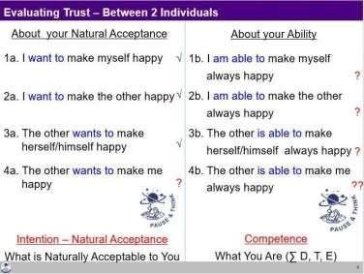

Distinguishing between Intention and Competence
Now if you try to analyse your own responses, many things will get clarified. You’ll find that while evaluating yourself, you evaluate on the basis of your intention (natural acceptance). You think that you are a good person as your intentions are good. On the other hand, when you evaluate the other, you evaluate him on the basis of his/her competence. You find that s(he) is not able to make you happy all the time. Many times, or most of the time he ends up making you unhappy. Therefore, you think that the other wants to make you unhappy. You have a doubt on other’s intention.
On the basis of lack of competence, we conclude about the lack of intention of the other. When we doubt their intention, instead of accepting the other as a relative, we have a feeling of opposition. This is the common mistake that we make in relationship today.

Now that we have clarity about intention and competence, explore this question:
If you have unconditional, continuous trust on intention, on the natural acceptance of the otherand if the other is lacking competence, what will you do?

- Try to improve upon his competence
- Get irritated
- Get angry
- Have a feeling of opposition

The answer is obviously (a). It is a response which indicates trust on intention. All other answers are reactions based on doubt on intention.

Now with these indicators, find out how many people are there in your life on whom you have trust on intention (natural acceptance) which is unconditional and continuous.

Generally, we don’t see intention and competence separately. Since competence is generally lacking, the feeling of unconditional acceptance is almost completely missing; rather there is a feeling of opposition. With that, we reinforce wrong assumptions like:
- Strangers can’t be trusted (?)
- Trust is developed over a long-time (?)
- Never trust anyone (?)
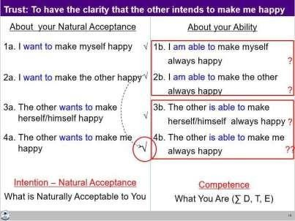
Thus, if we are able to see intention and competence distinctly, we will be able to place a tick mark in 4a. We will be assured of the intention of the other human being. And with that, we will make a programme of interaction with right evaluation of our competence and their competence (so, this is not ‘blind’ trust).
With the feeling of trust, one is able to see it clearly that the intention is same for all, to be happy and make other happy. The only difference lies in the level of competence.

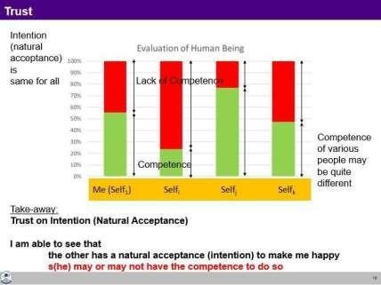

Key Takeaways
Trust is to be assured that the other has a natural acceptance (intention) to make me happy and prosperous. Trust on intention is the foundation of relationship. It is the beginning of mutual development. A common mistake is to evaluate oneself on the basis of one’s intention (and conclude that I am good) and the other on the basis of their lack of competence (thus doubt their intention and conclude that the other is bad).

Respect– As the Right Evaluation

Out of the nine feelings in relationship, we tried to understand the feeling of Trust. With trust on intention, the relationship starts. We will now explore the feeling of respect. Let us see, when do we feel respected? How do I respect others?

Feeling of Respect

Respect is right evaluation.

When we are rightly evaluated, we feel respected. When we are not rightly evaluated, we feel disrespected.

Disrespect can take place in three ways:
Over evaluation – evaluating for more than what it is Under evaluation – evaluating for less than what it is Otherwise evaluation – evaluating for other than what it is

If we look at our day-to-day behavior, we generally tend to do one of these three – over evaluation, under evaluation or otherwise evaluation. If any of these three takes place, the other person feels uncomfortable, disrespected.

Minimum Content of Respect – The Other is Similar to Me
When we evaluate the human being on the basis of Self, we are able to see that:
- Our purpose is the same – As I have a natural acceptance to live with continuous happiness and prosperity, it is same with the other. So, on the basis of our natural acceptance, we have the same purpose.

- Our programme is same – As my programme to achieve continuous happiness and prosperity is to understand the harmony and live in harmony at all levels of my being (from human being to the entire existence), it is same with the other. In that sense, our programme to fulfil our purpose is also same.

- Our potential is same – As I am endowed with natural acceptance and the activities of desire, thought and expectation are going on continuously in me, it is the same with the other. So, our potential is also same.

Thus, we can see that the other (Self) is similar to me. This is the minimum content of respect for a human being.

Disrespect Arising out of Differentiation leading to Discrimination
In general, what we are doing in the name of respect today is differentiating and discriminating.

First set of differentiation is on the basis of body– on the basis of age, gender, race and physical strength. This is based on the gross misunderstanding that human being = Body. The truth is that human being =co-existence of the Self and the Body.

The second set of differentiation is made on the basis of physical facility – on the basis of wealth and post. The gross misunderstanding here is that physical facility = happiness. The truth is that happiness is to be in a state of harmony.
The third basis of differentiation is on the basis of beliefs – on the basis of different isms (thought systems like socialism, capitalism, etc.), different sects, and different sets of information prevalent in the society. This is founded on the misunderstanding that if the pre-conditioning of the other matches with mine, then the other is respectable, otherwise not. The truth is that pre-conditioning and right understanding are two different things.

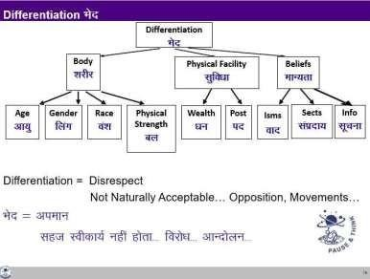
All this differentiation ultimately leads to discrimination, which is disrespect because it is not naturally acceptable.

Complete Content of Respect – We are Complementary to Each Other
At the level of the Self, only the competence could be different. Competence means how much of the potential of the Self has been realized. One Self may have realized more of its potential, while another may have realized less of its potential.

This difference in competence is to be complementary to each other (not to discriminate and exploit each other).

The complete content of respect is to be able to see that ‘the other is similar to me and we are complementary’.

Defining one’s complementarity:
- If the other has more understanding, is more responsible than me, I’m committed to understand from the other
- If I have more understanding than the other, I’m more responsible than the other. I live with responsibility with the other, unconditionally, unperturbed by the behaviour of the other. I am committed to facilitate the understanding in the other, once the other is assured in relationship and not before that

The complete content of respect is

- The other is similar to me in terms of purpose, programme and potential and
- We are complementary to each other in terms of competence
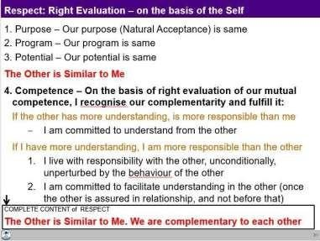

Thus, respect is right evaluation (of intention and competence on the basis of Self). We are similar at the level of purpose, programme and potential and we are complementary at the level of competence.

Disrespect arises out of over-evaluation, under-evaluation or otherwise-evaluation; and also, out of differentiation leading to discrimination on the basis of body, physical facility or beliefs. Small incidents of disrespect can have long-lasting consequences – from not speaking to each other, to opposition, break in relationship, divorce, fights and even war.

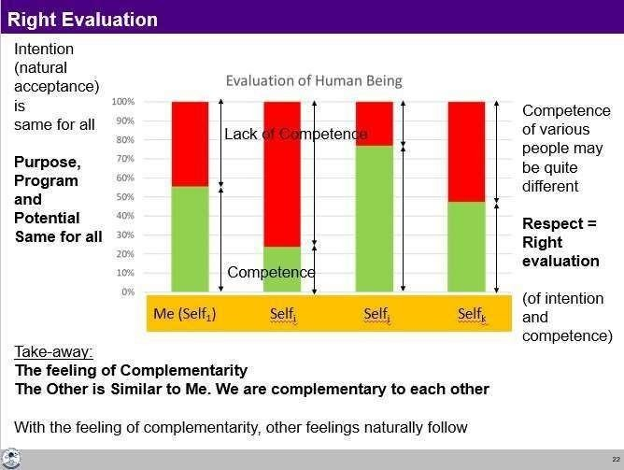

With the complete understanding of respect, we can see for every individual on the earth that we all are the same in terms of intention, program and potential. The only difference may lie in the level of competence. I may be having higher level of competence in relation to one, but may be having lower level of competence in relation to another. With this evaluation, one can work out the program to be complimentary to the other.
All the specific characteristics at the level of Body, physical facility, belief etc. can be used to express that complementarity.
e.g. a person with greater physical strength do the heavy work
e.g. a person at a higher post can work for the development of more people and so on

Key Takeaways
Respect is right evaluation at the level of the Self. The complete content of respect is to see that the other is similar to me in terms of purpose, programme and potential; and we are complementary to each other in terms of competence.
Over evaluation, under/otherwise evaluation and discrimination are disrespect.

Other Naturally Acceptable Feelings in Relationship
In the previous three lectures, we explored the feelings of trust and respect. Now, we will discuss otherfeelings, and understand our participation in the family.

- Affection

Affection is the feeling of being related to the other.

Affection is the feeling of acceptance for the other as one’s relative. Lack of affection is seen in the form of opposition, jealousy, etc. The feelings of trust and respect are essential to have the feeling of affection. When we have the feelings of trust, we feel related to the other; otherwise we may feel opposed to the other.

- Care

Care is the feeling of responsibility and commitment for nurturing and protection of the Body of my relative.
With the feeling of affection, one naturally takes the responsibility for development of the relative – both at the level of Self as well as at the level of Body. Being responsible to the Body of one’s relativeis Care.

- Guidance

Guidance is the feeling of responsibility and commitment for development of Self by ensuring the right understanding and right feeling in the Self of my relative.
Being responsible to the Self of my relative is Guidance.
Generally, our focus is mostly on care because we have come to assume that human being is Body. We are not even aware of the Self. Therefore, we are not aware that we have to take care of the Self as well.
- Reverence

Reverence is the feeling of acceptance for excellence.
Excellence is to be in a state of continuous happiness with the completeness of understanding of harmony and living in harmony at all levels. Once we achieve excellence, it continues. Excellence issomething definite, something absolute.

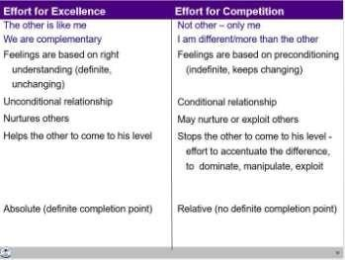

There is a basic difference between working for excellence and competition. If you have achieved excellence, you would naturally make effort for helping others to achieve excellence. On the other hand, in competition, we not only do not help rather we hinder the other to reach to our level.
- Glory

Glory is the feeling of acceptance for those who have made effort for excellence.
For all those people whom we call great people, when we accept the effort made for excellence by them, to whatever extent they are able to achieve it, we naturally have a feeling of glory for them.

- Gratitude

Gratitude is the feeling of acceptance for those who have made the effort for my excellence.

In our life, there may be so many people who have been of help to us in the process of understanding harmony and living in harmony. So, we have this feeling of gratitude for them. Gratitude is a significant feeling in the development of relationship.

- Love
Love is the feeling of being related to everyone, to all. It starts from affection, which we have already explored. If this feeling expands to many and ultimately to all, it is the feeling of love. So, we begin with the feeling of affection, and complete it with the feeling of love. That is why, Love is called complete value.

Love is the feeling of being related to all.

Love is expressed in the form of compassion. The feeling of love is for all and it is expressed to whosoever comes in contact.

Distinguishing Between Love and Infatuation
The feeling of love is not something which is based on sensation. If there is a feeling on the basis of sensation, this is the case of infatuation where the sensual pleasure becomes the major goal. Infatuation is conditional – it may last only as long as you are able to get the sensation or you have hope of getting happiness through sensation. It is very temporary; it does not last for long. Once the effect wears off, then the long-term issues of feelings become prominent.

Right Feeling – within Myself or from the Other?
With this background, we can ask ourselves which can have continuity:
- Right feeling in myself or
- Getting right feeling from the other
The answer is quite obvious that there can be continuity of right feeling, if it is from within and based on right understanding. But generally, we do keep making effort for getting right feeling from the other in continuity.

Role of Physical Facility in Fulfilment of Relationship
You can now see that physical facility has a limited role to play in the fulfilment of the feeling in human- human relationship. To fulfil the feeling of care, physical facility is certainly required. For other than the feeling of care, physical facility only has a symbolic role to play.

Response and Reaction in Behaviour
An important implication of understanding relationship, particularly trust on intention, is the clarity about problems in living in reaction and the possibility of living with response. With response, your conduct is definite while with reaction, the conduct is indefinite.

My Participation (Value) in Family
My participation (value) vis-à-vis my family is to ensure harmony in the family, ensure mutual happiness, ensure justice in the family by way of:
- Ensuring right feelings (trust, respect, affection, care, guidance, reverence, glory, gratitude and love) in myself – this leads to my happiness.

- Expressing (sharing) these feelings with the other. When the other is able to make the right evaluation of these feelings, it leads to his/her happiness, thus leading to mutual happiness. My participation is to be of help to the other in their self-evolution, self-development.
With this preparation in the family, I have the ability to participate meaningfully in the larger society –in the neighbourhood, in the community and so on.

Justice in Relationship
With the above discussion, justice can be understood.

Justice is the recognition, fulfilment and evaluation of human-human relationship, leading to mutual happiness.

To expand it a bit:
- Recognition of relationship means recognizing the naturally acceptable feelings in relationship rightly.
- Fulfilment of relationship means
  - Ensuring the naturally acceptable feelings in oneself.
  - Living with responsibility with the other with these feelings, forming the basis ofrelationship. This makes the other comfortable and assured.
  - Making effort for mutual development, i.e. development of one’s own competence and being of help to the other in developing their competence.
- Evaluation means verifying that I have the right feeling, I am able to express it properly, the right feeling has reached to the other and the other is able to identify it as the right feeling.

When the recognition, fulfilment and evaluation are right from my side, I feel happy. When the other is able to evaluate the expression of my feeling rightly, then (s)he also feels happy. Developing this competence may take time.

Justice is desirable in the family and beyond the family, all the way to the world family.

Key Takeaways
The other feelings in relationship include affection, care, guidance, reverence, glory, gratitude and love. Love is the feeling of acceptance of all; it is the complete value. Justice is ensuring these feelings in oneself and expressing them to the other, leading to mutual happiness. Justice begins from family and extends to the world family, leading to undivided society.

So far, we have explored harmony in the human being and harmony in the family. In the sequence, the next level of living for a human being is society. We can see very much see that we can conceive of a society only if it has families living together in a relationship of mutual fulfillment otherwise it is just like a crowd or battlefield.
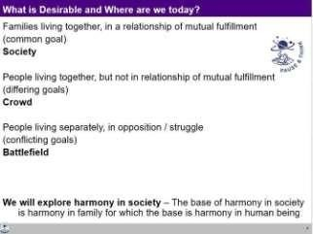

Understanding Human Goal
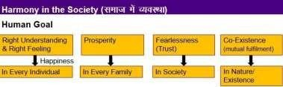
The goals of human being living in a society can be articulated as shown below:

We can explore and see what is naturally acceptable?
- Right understanding in every human being or only a few to have right understanding and others to follow them?
- Prosperity in every family or few families to have accumulation, and others to be deprived and dependent on the few?
- Fearlessness, based on trust and affection, in the society or a state of fear, based on mistrust and jealousy in the society?
- Co-existence (mutual fulfilment) in nature or exploitation and domination of nature?

Appraisal of the Current Status
As shown in the figure, due to the prevailing false assumptions of happiness (like money is everything), happiness is sought through accumulation of physical facility (money) by any means, and using it for getting sensations from the body or feelings from others. The second goal of prosperity is similarly seen as accumulating more and more. With these as the driving assumptions in the society, it has led to people living with three kinds of obsessions:

- Obsession for consumption
- Obsession for profit
- Obsession for sensual pleasure

Similarly, instead of the third goal of fearlessness (trust), we have domination, exploitation and fear in the society. Finally, instead of mutual fulfilment, we are mostly trying to exploit and be the master over nature.

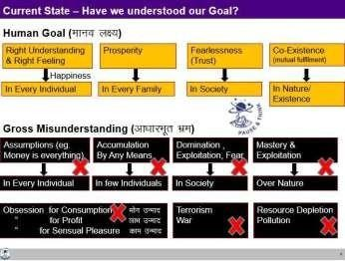

The Way Ahead
There is a need for understanding the harmony in society and living accordingly. The correct sequence in which these four goals can be fulfilled is shown in the figure below:
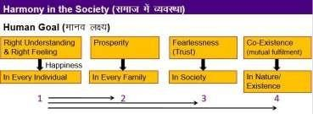

Dimensions (Systems) of Human Order
With the clarity of human goals, we can discuss five interconnected, complementary dimensions of human order required for the fulfilment of the human goal. The five basic systems of a human societyare:
- Education-Sanskar
- Health-Self regulation
- Production-Work
- Justice-Preservation
- Exchange-Storage

Though all are interconnected, we can see a primary link of the systems with the goals as:
Education- Sanskar (leads to) → Right understanding and right feeling (happiness)
Health-self-regulation → (leads to) → Prosperity Production-Work → (leads to) →Prosperity
Justice-Preservation -→ (leads to) → Fearlessness and Co-existence (respectively)
Exchange–storage → (leads to) →Prosperity and Fearlessness

Education-Sanskar

Looking at the first dimension of Education-Sanskar, as we discussed earlier, we can see that
Education is to develop right understanding of the harmony at all levels of being – from self to the entire existence (individual, family, society, and nature/existence).
and
Sanskar is to develop the basic acceptances of the harmony at various levels.

Education provides the commitment, preparation and practice of living in harmony at all levels. Preparation includes learning the skills and technology for living in harmony. Our living is an expression of our sanskar.
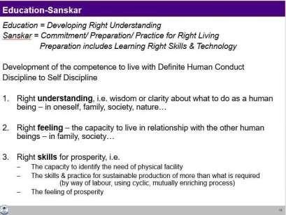

Health and Self-regulation
We had discussed this at length earlier.

Self-regulation is the feeling of responsibility towards the Body, for nurturing, protection and right utilization of the Body.

Health of the Body is indicated by the fact that it is able to act according to the instruction of the Self and the different parts of the Body are in harmony.

Production-Work

Work is the effort a human being does on the rest of nature and Production is the physical facility obtained from work.

There are two important issues related to production-work:
- What to produce?
- How to produce?

Regarding what to produce, we have already discussed while exploring the proposals about prosperity, health and self-regulation – we have to produce physical facility required for nurturing, protection and right utilisation of the Body.

Regarding how to produce there are two criteria:
- The process needs to be cyclic and mutually enriching – it has to be eco- friendly
- Justice needs to be ensured in relationship with human being – it has to be people-friendly
A production process is cyclic when the resources utilised in the process return to their original state in due course of their lifecycle. In the absence of being in tune with the natural processes, what we see ultimately is resource depletion and pollution.

Resource depletion is the symptom of using a natural resource at a rate which is greater than the rate at which it is produced in nature. For example, if we use forest at a rate greater than the rate at which itis produced in nature, there will be a shortage/ depletion of forest.

Similarly, pollution indicates that we are producing something which does not return to the cycle in nature or it is produced at a rate that is faster than the rate at which it can return to the cycle in nature. Plastic, for example, does not degrade, it does not return to the cycle of nature for many years.

Justice-Preservation
We had discussed about justice.

Justice is recognition of human-human relationship, its fulfilment and evaluation leading to mutual happiness.

We had discussed earlier that in human-human relationship, the feeling is the core issue. In order to ensure justice in the society, we need to develop the competence to understand and ensure justice in every individual. In case someone is not able to develop this competence and ends up doing in justice then:
- Stop the him from doing further injustice, as well as
- Help him/her to develop the competence for ensuring justice.
In the present system, mostly we seem to be restricting ourselves at (a) and not doing (b).

Preservation has to do with relationship of human being with the rest of nature. Preservation is the recognition of relationship of human being with the rest of nature, its fulfilment and evaluation leading to mutual fulfilment.

Precisely, preservation would mean enrichment, protection and right utilization of the
rest of the nature. Preservation ensures 1. Prosperity in human being
2. Enrichment, protection and right utilisation of the rest of the nature
Justice ensures fearlessness (trust) in the society and preservation ensures the mutual fulfilment (co-existence) with rest of the nature.

Exchange-Storage
Exchange means sharing or exchanging physical facility with a view of mutual fulfillment and not withthe obsession for profit.

The sharing is within the family, or to the extent one has been able to accept relationship. Beyond that is exchange. Through sharing and exchange of physical facility, each family can have all that it needs,
i.e. there is mutual fulfilment.
Storage is preserving physical facility after the fulfillment of needs, so that it is available, when required. This is done with a view of mutual fulfilment and not with the obsession for accumulation or exploitation.

Scope: Harmony from Family Order to World Family Order – Universal Human Order

The scope of the society is from family order to world family order. Every human being has a role in one or more of the social systems, starting from the family order, then the family cluster order and so on to the nation family order and ultimately, the world family order, leading to universal human order.

Family order refers to the system in a family of responsible people living together for the common human goal. The family cluster order is the next larger unit. It is the system that a group of families evolve in order to fulfil those goals of individual families which require the participation of more people than the family has. The scope of the system from the family order to the world family order is indicated below. It is ensured through successively larger and larger complementary units,
Family Order → Family Cluster Order → Village Order → Village Cluster Order
→ … → Nation Order… → World Family Order

Natural Outcome of Right Understanding
Now if you look at the basic human aspiration and its fulfilment:
- The happiness is ensured by having the right understanding and right feeling in the Self.
- The prosperity is a feeling of the availability of more than required physical facility. To ensure it, Right understanding is required at the base, along with physical facility.
- The tradition of living with happiness and prosperity starts from the family order and ultimately, continuity can be ensured by the universal human order.

In this way, the society with happiness in every individual, prosperity in every family, fearlessness (trust) in the society and co-existence (mutual fulfilment) in nature/existence is realized. This is one’s participation (value) vis-à-vis society.

Process of Development of a Child – In an environment of Relationship
A child intrinsically has a desire to understand what is right, to learn right skills and to do what is right This desire to understand is innate in every Self. This is the guidance that is expected by the child. The child wants to know about everything, so asks lots of questions, wants to relate to people around, picks up the language, the accent, the mannerisms… The thoughts and actions that lead to contradiction, thus unhappiness, are not satisfying for her/him, and hence the child makes a lot of effort in this direction from a very early age. It expects others to help him/her in learning and in understanding with a feeling of affection. In this process, the child starts with imitating, and then following. In time, progressing to obedience and discipline, all the time assuming the elders to be right. If (s) he is able to find answers and is able to validate them to be right, it leads to self-discipline and self- confidence in the child. The child’s conduct is definite and it is human.

On the other hand, if the child finds that the inputs are not right, it starts to have doubts on elders, teachers and hence tries out something on his/her own. If yet the knowing does not take place, the child’s conduct remains indefinite and inhuman. The people around the child then try to restrain the child by more instructions, more domination. Many of the bad habits form during this stage. It is basically that the child is trying ways and means of happiness or escaping from unhappiness. This further aggravates the state making way for dissatisfaction, lack of confidence, opposition, revolt, struggle and war. So, one has to find out where do we stand today? And what is the naturally acceptable way?

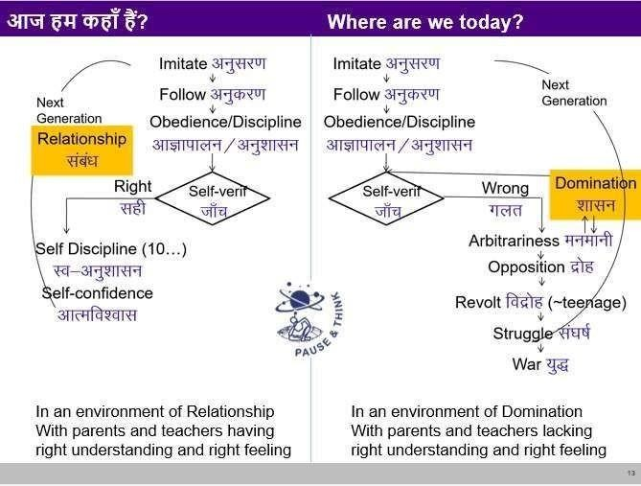

Key Takeaways
At the level of society, the human goal is right understanding and right feeling (happiness) in every individual, prosperity in every family, fearlessness (trust) in society and co-existence (mutual fulfilment) in nature/existence. This goal is fulfilled by human order, i.e. systems for education-sanskar, health-self regulation, production- work, justice-preservation and exchange-storage. These systems start with the family order, and are interconnected right up to world family order, leading to universal human order. The natural process of development of a child in an environment of relationship needs to be understood and fulfilled so that the child grows into a human being who can have the competence to participate in the universal human order.

